UMNROTCU MIDSHIPMAN HANDBOOK AND KNOWLEDGE PACKET

EXECUTIVE SUMMARY

This executive summary highlights to midshipmen (MIDN) stationed with the University of Michigan NROTC Unit items of importance contained within this manual.

This manual is intended to provide maximum uniformity and effectiveness in the application of NROTC policies and required knowledge. It applies to all MIDN at the University of Michigan Wolverine Battalion.

Guidance:

1. The purpose of this manual is to ensure all MIDN have access to required knowledge in preparation for inspections to be conducted by Unit staff members and battalion staff members, as well as information pertinent to successfully completing the NROTC program.

2. This manual is separated into two categories; the midshipman knowledge packet (section 1) and the midshipman handbook (section 2).

SECTION ONE

1. The information contained in this section is required to be memorized verbatim and may be requested at any time by any active duty staff member or a senior member of the battalion. If any information in this section is believed to be false, immediately notify Unit staff.

2. National Chain of Command.

a. President of the United States: President Barack Obama
b. Vice President of the United States: Vice President
Joseph R. Biden
c. Secretary of Defense: The Honorable Ashton Carter
d. Secretary of the Navy: The Honorable Ray Mabus
e. Chairman of the Joint Chiefs of Staff: General Joseph
Dunford, USMC
f. Chief of Naval Operations: Admiral John Richardson, USN
g. Vice Chief of Naval Operations: Admiral Bill Moran, USN
h. Commandant of the Marine Corps: General Robert B. Neller,USMC
i. Assistant Commandant of the Marine Corps: General Glenn M. Walters, USMC
j. Commander, Naval Education and Training Command: Rear
Admiral Michael S. White, USN
k. Commander, Naval Services and Training Command: Rear
Admiral Stephen C. Evans, USN
l. Master Chief Petty Officer of the Navy: Master Chief
Petty Officer Steven Giordano, USN
m. Sergeant Major of the Marine Corps: Sergeant Major
Ronald L. Green, USMC

3. UM NROTC Chain of Command.

a. Commanding Officer: Captain Christopher Dennis, USN
b. Executive Officer: Commander Leonard Haidl, USN
c. Operations Officer: Lieutenant Mark Guadagnini, USN
d. Marine Officer Instructor: 1st Lieutenant Matthew Stelmach, USMC
e. Submariner: Lieutenant Miguel Lewis, USN
f. Aviator: Lieutenant Mark Guadagnini, USN
g. Surface Warfare: Lieutenant David Denning, USN
h. Assistant Marine Officer Instructor: Gunnery Sergeant Derek Moore, USMC

4. UM NROTC Midshipman Chain of Command.

a. Battalion Commanding Officer: MCDR Marc Monahan
b. Battalion Executive Officer: MMAJ James Birmingham
c. Battalion Operations Officer: MLT Nicholas English
d. Battalion Command Sergeant Major: MSgtMaj Jake Holwerda

5. Facts and Terminology.

a. Navy Birthday: 13 October 1775
b. Father of the Navy: John Paul Jones
c. Navy Motto: Semper Fortis (Always Courageous)
d. | Marine | Corps | Birthday: 10 November 1775
e. | Marine | Corps | Birthplace: Tun Tavern (Philadelphia, PA)
f. | Marine | Corps | Motto: Semper Fidelis (Always Faithful)

6. Naval Core Values.

a. Honor
b. Courage
c. Commitment

7. Chief of Naval Operations’ Tenets.

a. War fighting first
b. Operate forward
c. Be ready

8. The NROTC Mission Statement.

a. The NROTC Program was established to develop Midshipmen mentally, morally and physically and to imbue them with the highest ideals of duty, and loyalty, and with the core values of honor, courage and commitment in order to commission college graduates as naval officers who possess a basic professional background, are motivated toward careers in the naval service, and have a potential for future development in mind and character so as to assume the highest responsibilities of command, citizenship and government.

9. The US Constitution Preamble.

We the People of the United States, in Order to form a more perfect Union, establish Justice, insure domestic Tranquility, provide for the common defense, promote the general Welfare, and secure the Blessings of Liberty to ourselves and our Posterity, do ordain and establish this Constitution for the United States of America.

10. Sailor’s Creed.

I am a United States Sailor.

I will support and defend the Constitution of the United States of America and I will obey the orders of those appointed over me.

I represent the fighting spirit of the Navy and those who have gone before me to defend freedom and democracy around the world.

I proudly serve my country’s Navy combat team with honor,
courage, and commitment.

I am committed to excellence and the fair treatment of all.

11. Military Code of Conduct.

1. I am an American, fighting in the forces which guard my country and our way of life. I am prepared to give my life in their defense.

2. I will never surrender of my own free will. If in command, I will never surrender the members of my command while they still have the means to resist.

3. If I am captured, I will continue to resist by all means available. I will make every effort to escape and aid others to escape. I will accept neither parole nor special favors from the enemy.

4. If I become a prisoner of war I will keep faith with my fellow prisoners. I will give no information or take part in any action which might be harmful to my comrades. If I am senior, I will take command. If not, I will obey the lawful orders of those appointed over me and will back them up in every way.

5. When questioned, should I become a prisoner of war, I am required to give name, rank, service number, and date of birth.
I will evade answering further questions to the utmost of my ability. I will make no oral or written statements disloyal to my country and its allies or harmful to their cause.

6. I will never forget that I am an American, fighting for freedom, responsible for my actions, and dedicated to the principles which made my country free. I will trust in my God and in the United States of America.

12. Eleven General Orders of a Sentry.

(Marine Corps version in parentheses)

1. To take charge of this post and all government property in view.

2. To walk my post in a military manner, keeping always on the alert and observing everything that takes place within sight or hearing.

3. To report all violations of orders I am instructed to enforce.

4. To repeat all calls from posts more distant from the guardhouse than my own.

5. To quit my post only when properly relieved.

6. To receive, obey, and pass on to the sentry who relieves me all orders from the Commanding Officer, Command Duty Officer, Officer of the Deck, and Officers, and Petty Officers of the Watch only. (To receive, obey and pass on to the sentry who relieves me all orders from the Commanding Officer, Officer of the Day, all Officers, and Non-Commissioned Officers of the guard only.)

7. To talk to no one except in the line of duty.

8. To give the alarm in case of fire or disorder.

9. To call the Officer of the Deck (Corporal of the Guard) in any case not covered by instructions.

10. To salute all officers and all colors and standards not cased.

11. To be especially watchful at night, and during the time for challenging, to challenge all persons on or near my post and to allow no one to pass without proper authority.

13. Leadership Principles.

1. Know yourself and seek self-improvement.
2. Be technically and tactically proficient.
3. Develop a sense of responsibility among your subordinates.
4. Make sound and timely decisions.
5. Set the example.
6. Know your Sailors/Marines and look out for their welfare
7. Keep your Sailors/Marines informed
8. Seek responsibility and take responsibility for your actions
9. Ensure assigned tasks are understood, supervised, and accomplished.
10. Train your Sailors/Marines as a team.
11. Employ your command in accordance with its capabilities.

14. 14 Leadership Traits (JJ DID TIE BUCKLE).

a. Justice
b. Judgment
c. Decisiveness
d. Integrity
e. Dependability
f. Tact
g. Initiative
h. Endurance
i. Bearing
j. Unselfishness
k. Courage
l. Knowledge
m. Loyalty
n. Enthusiasm

15. Phonetic Alphabet.

a. | Alpha | n. | November
b. | Bravo | o. | Oscar
c. | Charlie | p. | Papa (pah PAH)
d. | Delta | q. | Quebec (kay BECK)
e. | Echo | r. | Romeo
f. | Foxtrot | s. | Sierra
g. | Golf | t. | Tango
h. | Hotel | u. | Uniform
i. | India | v. | Victor
j. | Juliet | w. | Whiskey
k. | Kilo | x. | X-ray
l. | Lima | y. | Yankee
m. | Mike | z. | Zulu

16. Oath of Office.

I, _____, do solemnly swear (or affirm) that I will support and defend the Constitution of the United States against all enemies, foreign and domestic, that I will bear true faith and allegiance to the same; that I take this obligation freely, without any mental reservations or purpose of evasion; and that I will well and faithfully discharge the duties of the office on which I am about to enter. So help me God.

17. Midshipmen Chain of Command.

BATTALION COMMANDER MCDR/MLtCol.
EXECUTIVE OFFICER MLCDR/MMaj.
BATTALION CMC/SGTMAJ MMC/MSgtMaj.
PLATOON COMMANDER MLT/MCapt.
PLATOON LCPO/GySgt MCPO/MGySgt.
SQUAD LEADER MPO2/MSgt.

Specialty Billets:
OPERATIONS OFFICER MLT/MCapt.
ACADEMIC OFFICER MLT/MCapt.
ADMINISTRATIVE OFFICER MLTjg/M1stLt.
PUBLIC AFFAIRS OFFICER MLTjg/M1stLt.
SUPPLY OFFICER MLTjg/M1stLt
COLOR GUARD COMMANDER MENS/M2ndLt. (OPS DEPT)
DRILL TEAM COMMANDER MENS/M2ndLt. (OPS DEPT)
ATHLETIC OFFICER MENS/M2ndLt. (OPS DEPT)
RECRUITING OFFICER MENS/M2ndLt. (PA DEPT)
PELORUS OFFICER MENS/M2ndLt. (PA DEPT)
CONN/ALUMNI OFFICER MENS/M2ndLt. (PA DEPT)
PHYSICAL TRAINING INSTRUCTOR MENS/M2ndLt.

18. United States Navy and Marine Corps Enlisted Ranks.

Pay Grade | Navy Rank | Navy Insignia | Marine Rank | Marine Insignia
E-1 | Seaman Recruit | none | Private | none
E-2 | Seaman Apprentice | 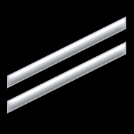 | Private First Class
E-3 | Seaman |  | Lance Corporal | 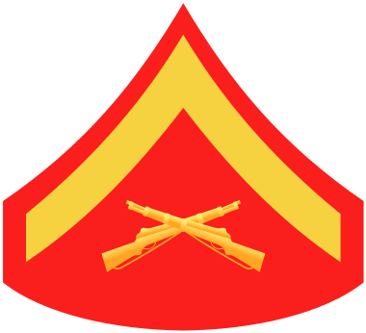
E-4 | Petty Officer  Third Class | 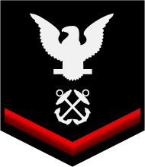 | Corporal | 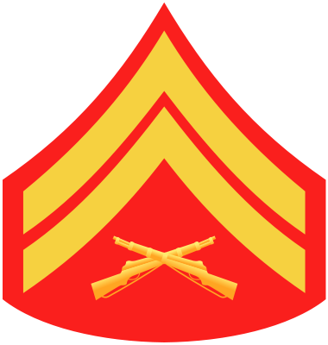
E-5 | Petty Officer  Second Class | 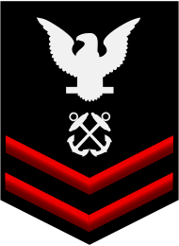 | Sergeant | 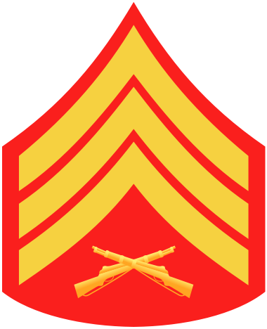
E-6 | Petty Officer  First Class | 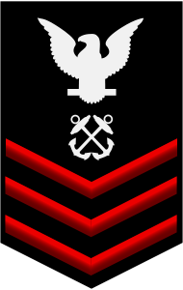 | Staff Sergeant | 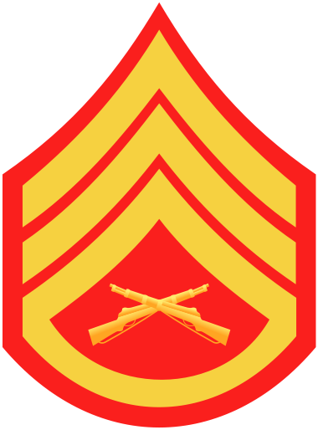
E-7 | Chief Petty Officer | 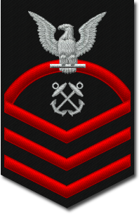 | Gunnery Sergeant | 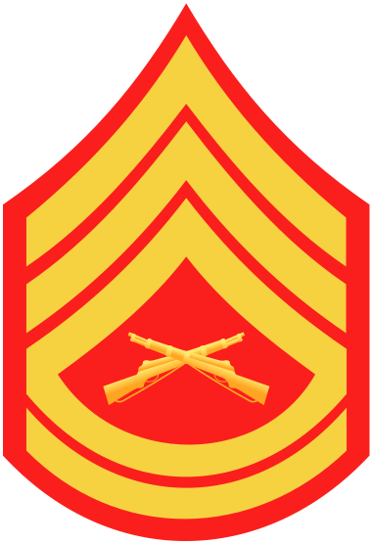
E-8 | Senior Chief  Petty Officer  (Silver stars) | 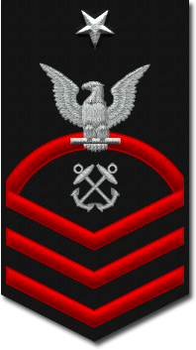 | Master Sergeant  First Sergeant | 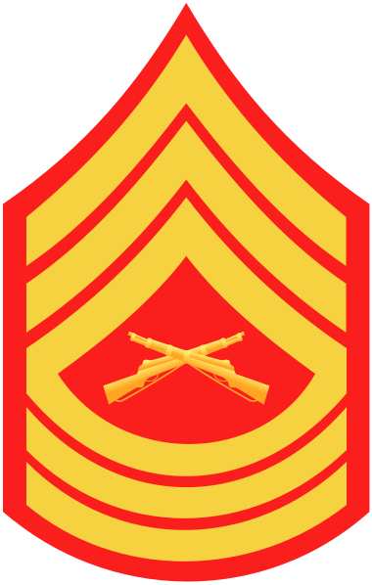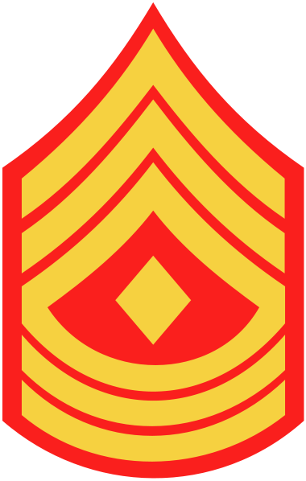
E-9 | Master Chief  Petty Officer  (Silver stars) | 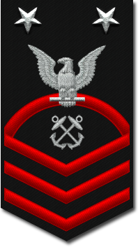 | Master Gunnery Sergeant  Sergeant Major | 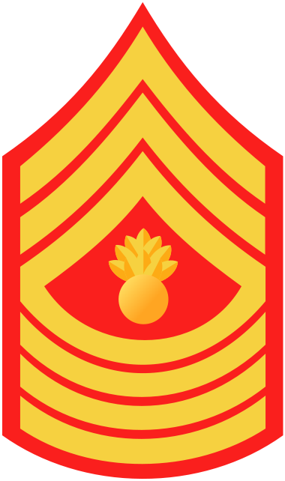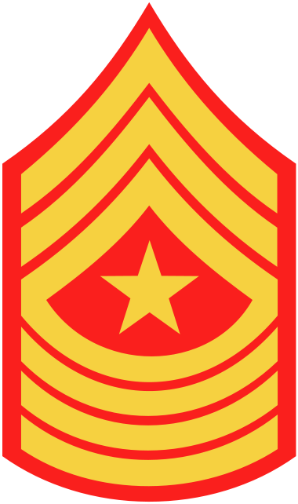
E-9 | Command Master Chief  (Silver stars) | 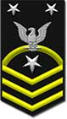
E-9 | Master Chief  Petty Officer  of the Navy  (Gold stars) | 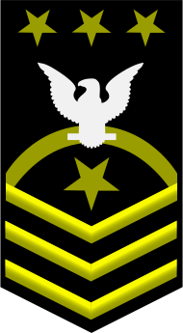 | Sergeant Major of the Marine Corps | 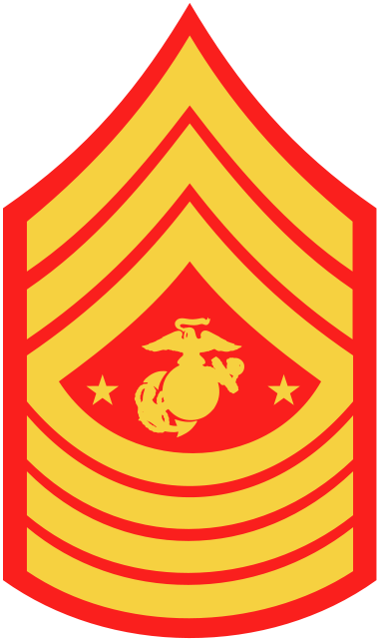

19. United States Army and Air Force Enlisted Ranks.

Pay Grade | Army Rank | Navy Insignia | Air Force Rank | Marine Insignia
E-1 | Private | none | Airman Basic | none
E-2 | Private |  | Airman
E-3 | Private First Class |  | Airman First Class
E-4 | Corporal  Specialist |  | Senior Airman
E-5 | Sergeant |  | Staff Sergeant
E-6 | Staff Sergeant |  | Technical Sergeant
E-7 | Sergeant First Class |  | Master Sergeant  First Sergeant
E-8 | Master Sergeant  First Sergeant |  | Senior Master Sergeant  First Sergeant
E-9 | Sergeant Major |  | Chief Master Sergeant  First Sergeant
E-9 | Sergeant Major of the Army |  | Chief Master Sergeant of the Air Force

20. United States Navy/Marine Corps/Army/Air Force Officer Ranks.

Pay Grade | Rank | Abbreviation | Collar | Shoulder | Sleeve
O-1 | Ensign/2nd Lieutenant | ENS/2ndLt
O-2 | Lieutenant  Junior Grade/1st Lieutenant | LTJG/1stLt
O-3 | Lieutenant/Captain | LT/Capt
O-4 | Lieutenant  Commander/Major | LCDR/Maj
O-5 | Commander/Lieutenant Colonel | CDR/LtCol
O-6 | Captain/Colonel | CAPT/Col
O-7 | Rear Admiral  (lower half)/Brigadier General | RDML/BGen
O-8 | Rear Admiral  (upper half)/Major General | RADM/MajGen
O-9 | Vice Admiral/Lieutenant General | VADM/LtGen
O-10 | Admiral/General | ADM/Gen

21. United States Navy Warrant Officer Ranks.

Pay Grade | Rank | Abbreviation | Collar | Shoulder | Sleeve
W-1 | Warrant Officer | WO1
W-2 | Chief  Warrant Officer | CWO2
W-3 | Chief  Warrant Officer | CWO3
W-4 | Chief  Warrant Officer | CWO4
W-5* | Chief  Warrant Officer | CWO5

22. United States Marine Corps Warrant Officer Ranks.

Pay Grade | Rank | Abbreviation | Collar
W-1 | Warrant Officer | WO1
W-2 | Chief  Warrant Officer | CWO2
W-3 | Chief  Warrant Officer | CWO3
W-4 | Chief  Warrant Officer | CWO4
W-5 | Chief  Warrant Officer | CWO5

23. United States Army Warrant Officer Ranks.

Pay Grade | Rank | Abbreviation | Collar
W-1 | Warrant Officer | WO1
W-2 | Chief  Warrant Officer | CWO2
W-3 | Chief  Warrant Officer | CWO3
W-4 | Chief  Warrant Officer | CWO4
W-5 | Chief  Warrant Officer | CWO5

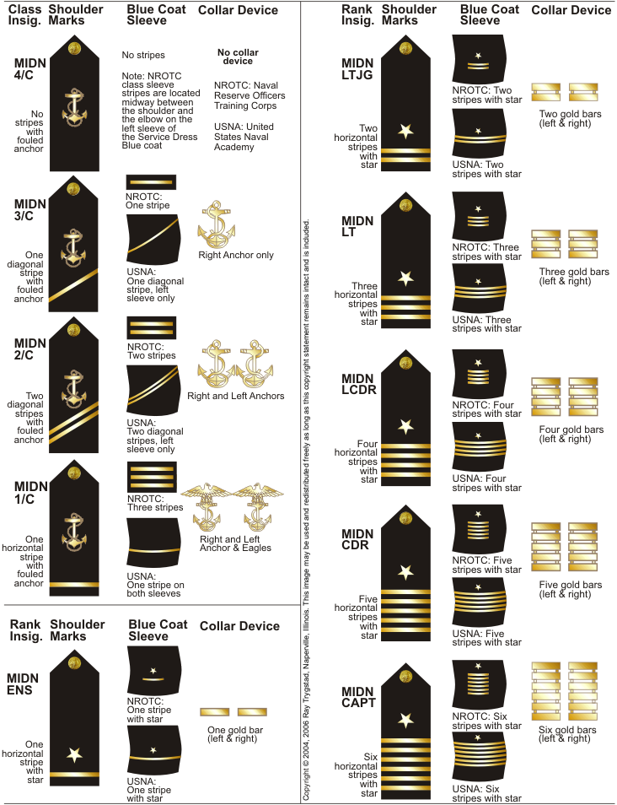
24. Midshipman Class and Billet Ranks.

25.
Anchors Aweigh.

Stand Navy out to sea
Fight our battle cry;
We'll never change our course
So vicious foes steer shy-y-y-y
Roll out the T. N. T.
Anchors Aweigh
Sail on to victory
And sink their bones to Davy Jones, hooray!

Anchors Aweigh my boys
Anchors Aweigh
Farewell to college joys (or "Farewell to foreign shores")
We sail at break of day-ay-ay-ay
Through our last night ashore
Drink to the foam
Until we meet once more
Here's wishing you a happy voyage home!

Blue of the Mighty Deep
Gold of God’s great sun
Let these our colors be
Till all of time be done, done, done, done
On seven seas we learn
Navy’s stern call
Faith, Courage, Service True
With Honor Over, Honor Over All.

26. Marines’ Hymn.

From the Halls of Montezuma
To the Shores of Tripoli;
We fight our country's battles
In the air, on land and sea; First to fight for right and freedom And to keep our honor clean;
We are proud to claim the title
of United States Marine.

Our flag's unfurled to every breeze
From dawn to setting sun;
We have fought in ev'ry clime and place
Where we could take a gun;
In the snow of far-off Northern lands
And in sunny tropic scenes;
You will find us always on the job--
The United States Marines.

Here's health to you and to our Corps
Which we are proud to serve
In many a strife we've fought for life
And never lost our nerve; If the Army and the Navy
Ever look on Heaven's scenes;
They will find the streets are guarded
By United States Marines.

27. Midshipmen Uniform Regulations.

a. Navy Working Uniform

Collar devices. Center insignia one inch from the front and lower edges of the collar and position it with the vertical axis of the insignia along an imaginary line bisecting the angle of the collar point. Bitter end of the fouled anchor chain points outboard. Fourth class do not wear collar devices; third class wear Navy anchor on right collar only; second class wear Navy anchor on both collars; first class wear Navy eagle and anchor on both collars. Midshipman Officer billet insignia are positioned identically to class insignia.

b. Marine Corps Combat Utility Uniform

Collar devices. The Eagle, Globe, and Anchor insignia is worn centered, one inch from the front edge of the collar, with the wings of the eagle parallel to the deck. Officer insignia is worn in the same manner, with vertical axis of the bars parallel to the deck. Fourth class do not wear collar insignia; third class wear insignia on right collar only; second and first class wear collar insignia on both sides.

c. Service Khakis

Collar devices. Center insignia one inch from the front and lower edges of the collar and position it with the vertical axis of the insignia along an imaginary line bisecting the angle of the collar point. Bitter end of the fouled anchor chain points outboard. For Navy options, fourth class do not wear collar devices; third class wear Navy anchor on right collar only; second class wear Navy anchor on both collars; first class wear Navy eagle and anchor on both collars. Midshipman Officer billet insignia are positioned identically to class insignia. For Marine Options, the Eagle, Globe, and Anchor insignia is worn centered, one inch from the front edge of the collar, with the wings of the eagle parallel to the deck. Officer insignia is worn in the same manner, with vertical axis of the bars parallel to the deck. For Marine options, fourth class do not wear collar insignia; third class wear insignia on right collar only; second and first class wear collar insignia on both sides.

Nametag Placement. Worn centered above right breast pocket. 0.25” gap between top of pocket and bottom of nametag for Navy Options, 0.125” gap for Marine Options.

Ribbon Placement. Worn centered above left breast pocket. 0.25” gap between top of pocket and bottom of ribbons for Navy Options, 0.125” gap for Marine Options.

Cover Insignia Placement. The insignia is attached to the left side of the garrison cap, shank perpendicular to the ground, 2” from the front edge. For males it is 1 1⁄2” from the bottom edge of the cover to the center of the insignia. For females it is centered between the top and bottom edges of the cap apron. The Navy device is the 1” fouled anchor; the Marine device is the small USMC cap insignia.
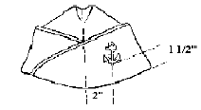
d. Service Dress Blues

Collar devices. For Navy Options, large anchor devices are centered above the notch in the collar with the shank parallel to the collar seam. It shall be pinned on each collar tip of the coat so that the crown of the anchor is 1/2" above the notch of the lapel (males), 1" from the bottom and midway between the two sides (female), and the shank is parallel to and approximately 3/4" from the outer edge of the collar. The lower end of the stock shall be outboard and the stock shall be approximately horizontal. For Marine Options, large Eagle, Globe, and Anchor devices are worn in the same place as Navy Option anchors; the eagle’s wings are parallel to the deck.
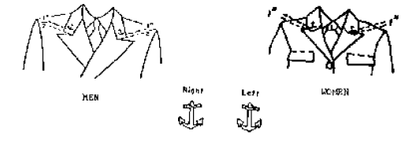

Nametag Placement. Worn centered above where right breast pocket would be, if it were to mirror left breast pocket. 0.25” gap between top of pocket and bottom of nametag for Navy Options, 0.125” gap for Marine Options.

Ribbon Placement. Worn centered above left breast pocket. 0.25” gap between top of pocket and bottom of ribbons for Navy Options, 0.125” gap for Marine Options.

Shoulder Boards. Bitter ends of anchor insignia point aft. For Marine Options, shoulder boards are worn such that eagle’s wings are parallel to shoulder seam. Fourth class have no gold stripes; third class have one diagonal stripe; second class have two diagonal stripes; first class have one horizontal stripe.

Class sleeve insignia. Horizontal gold stripes, sewn on the left sleeve midway between the elbow and the shoulder, are worn on the Service Dress Blue Uniform. First class wear three; second class, two; third class, one; fourth class, none. Stripes are made of gold nylon braid 1-1/2 inches long and 1/8 inch wide with 1⁄4 inch spacing.

Officer Insignia. Worn on both sleeves of the Service Dress Blue Coat centered on the outside of the sleeve 2” above and parallel to the edge of the cuff. The gold star is centered above the stripes with one ray pointing down and the point 3⁄4” above the uppermost stripe.

Enlisted Insignia. Worn on the outside right sleeve of the Service Dress Blue Coat halfway between the elbow and the shoulder.

Cover. Black elastic band is to be pulled parallel and flush with white border; anchor screws on sides of cover are to be rotated such that eagles are vertically aligned.

e. Service Dress Whites

Shoulder Boards. Bitter ends of anchor insignia point aft. For Marine Options, shoulder boards are worn such that eagle’s wings are parallel to shoulder seam. Fourth class have no gold stripes; third class have one diagonal stripe; second class have two diagonal stripes; first class have one horizontal stripe.

Nametag Placement. Nametag not worn with Service Dress Whites.

Ribbon Placement. Ribbons not worn with Service Dress Whites.

Cover. Black elastic band is to be pulled parallel and flush with white border; anchor screws on sides of cover are to be rotated such that eagles are vertically aligned.

f. Summer Whites

Shoulder Boards. Bitter ends of anchor insignia point aft. For Marine Options, shoulder boards are worn such that eagle’s wings are parallel to shoulder seam. Fourth class have no gold stripes; third class have one diagonal stripe; second class have two diagonal stripes; first class have one horizontal stripe.

Nametag Placement. Worn centered above right breast pocket. 0.25” gap between top of pocket and bottom of nametag for Navy Options, 0.125” gap for Marine Options.

Ribbon Placement. Worn centered above right breast pocket. 0.25” gap between top of pocket and bottom of ribbons for Navy Options, 0.125” gap for Marine Options.

Cover. Black elastic band is to be pulled parallel and flush with white border; anchor screws on sides of cover are to be rotated such that eagles are vertically aligned.

SECTION TWO

Amplifying Guidance and Instructions:
1. Communication. Midshipmen are responsible for ALL methods used to communicate within the Battalion and among the staff. This includes, but are not limited to, email, which shall be read at least three times daily, land line and/or cellular telephone calls, Battalion formations, as scheduled by the Battalion Commander and/or the active duty staff, Class Advisor meetings, bulletin boards within the unit, published notices, and policy statements and guidance.
Midshipmen must immediately report any and all significant or incapacitating injuries or illness to their Class Advisor and the AMOI. Incapacitating injury or illness is one that precludes attendance at class, drill, or prescribed Battalion activities (including PT). All Midshipmen shall attend functions if safe to do so but may be excused by the cognizant Unit staff member as appropriate.

2. Academics. Members of the Battalion shall take a minimum of 12 credit hours per semester during the fall and winter terms, not including Naval Science courses. OCs and MECEPs shall take a minimum of 6 semester hours during the Spring/Summer terms.

Class Attendance is mandatory for all registered classes.

The average course load for a semester is between 15 and 18 credit hours, including Naval Science (NS) classes. A course load of fewer than 15 credits or greater than 18 credits must be approved by the student’s Class Advisor. A course load of less than 12 credits or greater than 20 credits in a semester requires Commanding Officer approval via Class Advisor.

Any student desiring to switch majors must have the Commanding Officer’s approval prior to switching with the University.

For all NROTC required courses, the student must earn a “C-“ or better to receive credit. Failure to meet this requirement may result in the student retaking the class at his/her own expense – including all tuition and fees necessary for completion of the NROTC requirement.

Midshipmen unable to maintain a 3.0 GPA, or are an entering 4/C Midshipman, shall adhere to the requirements below:

Battalion Academic Study Hours Requirements:

- 10 hours per week for a GPA below 2.79
- 5 hours per week for a GPA between 2.80 and 2.89
- 3 hours per week for a GPA between 2.90 and 2.99
- No required study hours for a GPA above 3.0
- 3 hours per week for ALL incoming 4/C Midshipmen during Fall Semester

3. Navy Option Scholarship Students. These students are required to complete course sequences in calculus and physics equivalent to at least six semester hours in each area.

a. Calculus. The calculus sequence shall include material through differential and integral calculus of one real variable.
b. Physics. The physics sequence shall be calculus-based and cover the traditional topics of mechanics, electricity, magnetism, sound, optics, heat, and other related subject matter. Students shall include appropriate laboratory classes in completing the physics requirement.
c. Students who complete calculus and physics courses at institutions other than the host institution must ensure credits with a letter grade are transferable before use for the Navy
d. Students shall complete calculus by the end of the second year of Naval Science (normally the sophomore year) and physics by the end of the third year of Naval Science (normally the junior year). PNS shall place students not completing this requirement or failing to schedule these courses to ensure timely completion on academic LOA pending completion. In certain instances, NSTC OD3 may grant a time-of-completion waiver.
e. Students who have taken calculus or calculus-based physics for college credit in high school, which the college has validated, must complete one additional three semester-hour (or equivalent) college course in each of those areas to satisfy this requirement.

4. Navy College Program Students.

a. Basic Course. The NROTC College Program is offered to college students who wish to serve their country as commissioned officers, but who have not been awarded any form of an NROTC scholarship. College Program students are selected from those who have applied for enrollment at the NROTC unit and sign a contract in which they agree to complete certain

Naval Science courses and one summer training period (if selected for Advanced Standing). The Basic Course of the College Program is designed for those students with at least three years of college coursework remaining. While in the Basic Course, students have the status of civilians.

b. Advanced Course. NROTC College Program students are considered to be in Advanced Standing if they are selected by NSTC OD2 or Marine Corps Recruiting Command (MCRC) for Advanced Standing, accepted in the Advanced Course by the PNS, found physically qualified by Depart of Defense Medical Review Board (DoDMERB) and attend the third year of the Naval Science course. NROTC College Program Advanced Standing includes the third and fourth year of Naval Science classes and First Class (1/C) summer training. Every student selected for the Advanced
Course must enlist in the Naval or Marine Corps Reserve prior to commencing the Advanced Course. In return for enlistment and acceptance into the Advanced Course, the Navy will provide each
Advanced Standing student uniforms, Naval Science textbooks, and a subsistence allowance for a maximum of 20 months. The NROTC College Program student, upon graduation and completion of Naval Science requirements, will be commissioned as an ensign in the Navy or as a second lieutenant in the Marine Corps.

5. Other NROTC-Specified Academic Requirements.

a. American History/National Security Policy Courses.
These courses shall focus on U.S. military history, world military history, U.S. National Security policy, or combinations of these topics. The PNS shall approve these courses.
b. World Culture and Regional Studies Courses. These courses must have an emphasis on Third World, Far East, and/or Southwest Asia. This academic requirement is designed to expand our future officer corps‟ awareness, knowledge, and sensitivity to world cultures and peoples. The PNS shall approve these courses.
c. English Courses. These courses, which total six semester-hours or equivalent, must concentrate on the areas of grammar and composition and require significant student writings. The PNS shall approve these courses.

Courses | Completed by end of year: | Minimum  Semester  Hours | USN | USMC | USN CP | USMC CP | Nurse | STA- 21
Calculus | Sophomore | 6 | R | A | A | A | N | P
Physics  With Lab | Junior | 6 | R | A | A | A | N | P
College  Algebra or  Advanced  Trigonometry | Junior |  | -- | -- | R | A | N | P
Physical  Science | Senior | 6 | -- | -- | R | A | N | P
American  History or  National  Security  Policy | Senior | 3 | R | R | R | R | N | P
World Culture  and Regional  Studies | Senior | 3 | R | A | R | A | R | P
English | Sophomore | 6 | R | R | R | R | R | R
Table 4-1: Specified Courses
R = Required
A = Advised to ease change to USN scholarship status
N = Not required by Navy
P = Per program authorizations

6. Fraternization. No 1/C, 2/C, or 3/C Midshipman shall date a 4/C Midshipman. Active duty personnel (including MECEPS, MCPs and OCs) are prohibited from dating any Midshipman.

7. EMU Naval Science. EMU students will attend Naval Science courses at UM in consultation with the course instructor. There is no formal enrollment procedure through EMU for NROTC courses. However, NROTC course grades are a part of a Midshipman's overall GPA that is reported in OPMIS. EMU students who complete the NROTC Program can be given credit for 20 hours of military science towards graduation and given a minor in Military Science, which appears on their final transcript. This minor must be set up between the student and their academic advisor at EMU.

8. Drill Waiver and Unauthorized Absence Policy.

a. Term Drill Waivers. Term drill waivers will not be issued except in extraordinary circumstances. There will be two drill periods offered, a primary and alternate. Drill is not an optional course; it is required and midshipmen will attend one of the drill periods. If a class conflict arises, the midshipman must determine if it can be taken at another time. If the course is an elective that can be fulfilled by another class at a different time, a waiver will not be granted. Waivers to attend the alternate drill period are to be submitted via a request chit through the Platoon GySgt/LCPO, Platoon Commander, and Unit Advisor. A copy will then be sent to the AMOI and Battalion Operations Officer. Class schedules highlighting time conflicts and a listing of degree requirements highlighting the absolute need for the waiver shall be included with the request. These items will be submitted the term PRIOR to the term the waiver is needed. Work requirements will not be considered in this process.

b. Individual Drill Waiver. These will not be issued except in extraordinary circumstances. Waivers are to be submitted via a request chit to the Platoon Commanders via the Platoon SGT/LPO. Platoon Commanders will copy the Unit Advisor, AMOI and Battalion Operations Officer. The submission of the request will occur no later than 96 hours prior to the event, unless there are extenuating circumstances that prohibit timely submission. Once the chit has been submitted, the Midshipman will be informed of the approval/disapproval of the chit within 72 hours.

c. Unauthorized Absence (UA). If a waiver is not routed up through the Chain of Command and a mandatory event is missed, the MIDN will be considered UA and corrective action will be taken. Mandatory events include, but are not limited to, all classes for which a Midshipman is registered, Physical Training (PT), and the Weekly Drill period.

9. SWIMMING.

As members of the sea services, Midshipmen are required to meet the swimming standards for accession into the naval service. Therefore, all Midshipmen are required to qualify as third class swimmers by the end of their freshman year or they will be placed on a leave of absence. Midshipmen who fail the swim test at the end of their 4/C year will be placed on Aptitude Warning and will be required to enroll in a Red Cross-certified swimming course (either through the host university or local YMCA/etc.). Midshipmen who fail to qualify as a third class swimmer at any time after their freshmen year shall be placed

in a Leave of Absence status, or recommended for disenrollment as appropriate.

a. 3rd Class Swimmer. A 3rd Class Swimmer is described as a person who can stay afloat and survive without the use of a Personal Floatation Device (PFD) in open water under optimum conditions long enough to be rescued in a man-over-board situation. The 3rd Class Swimmer qualification is the minimum entry-level requirement for all U.S. Navy personnel. The test requires a student to complete a 50-yard swim using any stroke, a deep water jump, prone float, and trouser and blouse inflation.

b. 2nd Class Swimmer. A 2nd Class Swimmer is described as a person who can stay afloat and survive without the use of a PFD indefinitely under optimum conditions. The 2nd Class Swimmer qualification is used as an entry-level requirement for Small Boat Operators, Naval Air Crewman, and Rescue Swimmers. The test requires a student to complete a deep water jump, 100-yard swim using the crawlstroke, breaststroke, elementary backstroke, and sidestroke (25 yards each), prone float, back float, and trouser and blouse inflation.

c. Administration. The swimming test will be administered two times throughout the academic year. The first time, held early in September, is mandatory for all incoming midshipmen. The test will also be given during the winter term and is required for all midshipmen who have not received a 3rd class qualification or higher within the past year. The test will be taken annually until a midshipman is second class swim qualified.

8. MIDSHIPMEN AWARDS

PRECEDENCE NATIONAL AWARDS DEVICE

1 Society of American Military Engineers Medal/Ribbon
2 American Defense Preparedness Association Medal/Ribbon
3 American Legion Award Medal/Ribbon
4 Daughters of the American Revolution Medal/Ribbon
5 Legion of Valor of the United States Medal/Ribbon
6 Military Order of the World Wars Medal/Ribbon
7 Sons of the American Revolution Medal/Ribbon
8 Daughters of Founders and Patriots Medal/Ribbon
9 General Society of the War of 1812 Medal/Ribbon
10 National Sojourners Award for Americanism Medal/Ribbon
11 Reserve Officers Association Award Medal/Ribbon
12 Veterans of Foreign Wars Award Medal/Ribbon

NROTC AWARDS

13 All Around Performance Ribbon
14 Academic Excellence (for 3.75-4.00 GPA) Ribbon
15 Academic Achievement (for 3.50-3.74 GPA) Ribbon
16 Commendation Award Ribbon
17 Leadership Award Ribbon
18 Community Service Ribbon
19 Physical Fitness (Outstanding) Ribbon
20 Drill Team Ribbon
21 Color Guard Ribbon
22 Intramurals Ribbon
23 Rifle/Pistol Team Ribbon
24 Sailing Award Ribbon
25 Recruiting Ribbon
26 Platoon Comp Ribbon
27 Cruise Ribbon

Gold Star (in lieu of second award)
Silver Star (in lieu of fifth Gold Star
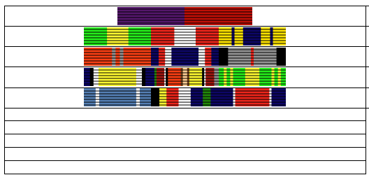

References

The following are ready references, which provide amplifying information regarding various pertinent programs within the Navy and Marine Corps. Prior to inquiry of the chain of command or Academic Advisor, Midshipmen should make every effort to determine the correct course of action outlined in the applicable reference. These references may be found via an Internet source or your Academic Advisor.

References (listed in no particular order):
● NROTC Unit Operations
CNSTCINST 1533.2 Regulations for Officer Development
● Uniform Regulations (Navy)
NAVPERS 15665I
● Uniform Regulations (Marine Corps)
MCO P1020.34
● Drug and Alcohol Prevention Programs
OPNAV 5350.4 Series
● General Military Requirements/Enlisted Guidance (Navy)
Blue Jackets Manual
● Physical Readiness Program (Navy)
OPNAVINST 6110.10 Series
● Physical Readiness Program (Marine Corps)
MCO P6100.12
● Fitness Reports and Evaluations (Navy)
BUPERSINST 1610.10 Series
● Collision Avoidance Regulations (Marine Navigation)
COMDTINST 16672.2 Series

