UNIVERSITY OF MICHIGAN NROTC MIDSHIPMAN KNOWLEDGE PACKET

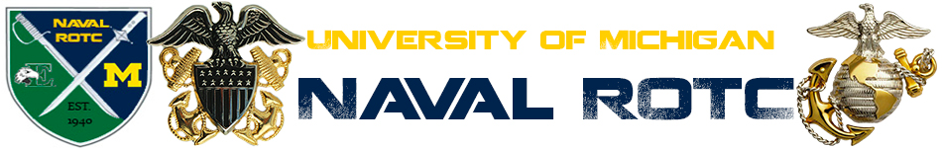

Fall
2015

1. This information is required to be memorized verbatim and may be requested at any time by any active duty staff member or a senior member of the Battalion.

2. National Chain of Command:

a. President of the United States: President Barack Obama b. Vice President of the United States: Vice President
Joseph R. Biden
c. Secretary of Defense: The Honorable Ashton Carter
d. Secretary of the Navy: The Honorable Ray Mabus
e. Chairman of the Joint Chiefs of Staff: General Martin
Dempsey, USA
f. Chief of Naval Operations: Admiral John Richardson, USN
g. Vice Chief of Naval Operations: Admiral Michelle Howard, USN
h. Commandant of the Marine Corps: General Robert B. Neller,USMC
i. Assistant Commandant of the Marine Corps: General John M.
Paxton, USMC
j. Commander, Naval Education and Training Command: Rear
Admiral Michael S. White, USN
k. Commander, Naval Services and Training Command: Rear
Admiral Richard A. Brown, USN
l. Master Chief Petty Officer of the Navy: Master Chief
Petty Officer Michael Stevens, USN
m. Sergeant Major of the Marine Corps: Sergeant Major
Ronald L. Green, USMC

3. UM NROTC Chain of Command:

a. Commanding Officer: Captain Joseph Evans, USN
b. Executive Officer: Commander Leonard Haidl, USN c. Operations Officer: Lieutenant Patrick Love, USN
d. Marine Officer Instructor: Captain Brian Kerg, USMC
e. Submariner: Lieutenant Miguel Lewis, USN
f. Aviator: Lieutenant Mark Guadagnini, USN
g. Surface Warfare Officer: Lieutenant Patrick Love, USN
h. Assistant Marine Officer Instructor: Gunnery Sergeant Derek Moore, USMC

4. UM NROTC Midshipman Chain of Command:

a. Battalion Commanding Officer: MLtCol Ajalon St. Charles
b. Battalion Executive Officer: MLCDR John Trethewey
c. Battalion Operations Officer: MLT Nathan Redder
d. Battalion Command Master Chief: MCPO Wesley Howell

5. Facts and Terminology:

a. Navy Birthday: 13 October 1775
b. Father of the Navy: John Paul Jones
c. Navy Motto: Semper Fortis (Always Courageous)

d. | Marine | Corps | Birthday: 10 November 1775
e. | Marine | Corps | Birthplace: Tun Tavern (Philadelphia, PA)
f. | Marine | Corps | Motto: Semper Fidelis (Always Faithful)

6. Naval Core Values:

a. Honor
b. Courage
c. Commitment

7. Chief of Naval Operations’ Tenets:

a. War fighting first b. Operate forward
c. Be ready

8. The NROTC Mission Statement:

a. The NROTC Program was established to develop Midshipmen mentally, morally and physically and to imbue them with the highest ideals of duty, and loyalty, and with the core values of honor, courage and commitment in order to commission college graduates as naval officers who possess a basic professional background, are motivated toward careers in the naval service, and have a potential for future development in mind and
character so as to assume the highest responsibilities of command, citizenship and government.

9. The US Constitution Preamble:

a. We the People of the United States, in Order to form a more perfect Union, establish Justice, insure domestic Tranquility, provide for the common defense, promote the general Welfare, and secure the Blessings of Liberty to ourselves and our Posterity, do ordain and establish this Constitution for the United States of America.

10. Sailor’s Creed:

I am a United States Sailor.

I will support and defend the Constitution of the United States of America and I will obey the orders of those appointed over me.

I represent the fighting spirit of the Navy and those who have gone before me to defend freedom and democracy around the world.

I proudly serve my country’s Navy combat team with honor,
courage, and commitment.

I am committed to excellence and the fair treatment of all.

11. Military Code of Conduct:

1. I am an American, fighting in the forces which guard my country and our way of life. I am prepared to give my life in their defense.

2. I will never surrender of my own free will. If in command, I will never surrender the members of my command while they still have the means to resist.

3. If I am captured, I will continue to resist by all means available. I will make every effort to escape and aid others to escape. I will accept neither parole nor special favors from the enemy.

4. If I become a prisoner of war I will keep faith with my fellow prisoners. I will give no information or take part in any action which might be harmful to my comrades. If I am senior, I will take command. If not, I will obey the lawful orders of those appointed over me and will back them up in every way.

5. When questioned, should I become a prisoner of war, I am required to give name, rank, service number, and date of birth.
I will evade answering further questions to the utmost of my ability. I will make no oral or written statements disloyal to my country and its allies or harmful to their cause.

6. I will never forget that I am an American, fighting for freedom, responsible for my actions, and dedicated to the principles which made my country free. I will trust in my God and in the United States of America.

12. Eleven General Orders of a Sentry:
(Marine Corps version in parentheses)

1. To take charge of this post and all government property in view.

2. To walk my post in a military manner, keeping always on the alert and observing everything that takes place within sight or hearing.

3. To report all violations of orders I am instructed to enforce.

4. To repeat all calls from posts more distant from the guardhouse than my own.

5. To quit my post only when properly relieved.

6. To receive, obey, and pass on to the sentry who relieves me all orders from the Commanding Officer, Command Duty Officer, Officer of the Deck, and Officers, and Petty Officers of the Watch only. (To receive, obey and pass on to the sentry who relieves me all orders from the Commanding Officer, Officer of the Day, all Officers, and Non-Commissioned Officers of the guard only.)

7. To talk to no one except in the line of duty.

8. To give the alarm in case of fire or disorder.

9. To call the Officer of the Deck(Corporal of the Guard) in any case not covered by instructions.

10. To salute all officers and all colors and standards not cased.

11. To be especially watchful at night, and during the time for challenging, to challenge all persons on or near my post and to allow no one to pass without proper authority.

13. Leadership Principles:

1. Know yourself and seek self-improvement.
2. Be technically and tactically proficient.
3. Develop a sense of responsibility among your subordinates.
4. Make sound and timely decisions.
5. Set the example.
6. Know your Sailors/Marines and look out for their welfare
7. Keep your Sailors/Marines informed
8. Seek responsibility and take responsibility for your actions
9. Ensure assigned tasks are understood, supervised, and accomplished.
10. Train your Sailors/Marines as a team.
11. Employ your command in accordance with its capabilities.

14. 14 Leadership Traits (JJ DID TIE BUCKLE):

a. Justice b. Judgment
c. Decisiveness
d. Integrity
e. Dependability f. Tact
g. Initiative h. Endurance i. Bearing
j. Unselfishness k. Courage
l. Knowledge m. Loyalty
n. Enthusiasm

15. Phonetic Alphabet:

a. | Alpha | n. | November
b. | Bravo | o. | Oscar
c. | Charlie | p. | Papa (pah PAH)
d. | Delta | q. | Quebec (kay BECK)
e. | Echo | r. | Romeo
f. | Foxtrot | s. | Sierra
g. | Golf | t. | Tango
h. | Hotel | u. | Uniform
i. | India | v. | Victor
j. | Juliet | w. | Whiskey
k. | Kilo | x. | Xray
l. | Lima | y. | Yankee
m. | Mike | z. | Zulu

16. United States Navy and Marine Corps Enlisted Ranks:

Pay Grade | Navy Rank | Navy Insignia | Marine Rank | Marine Insignia
E-1 | Seaman Recruit | none | Private | none
E-2 | Seaman Apprentice |  | Private First Class
E-3 | Seaman |  | Lance Corporal | 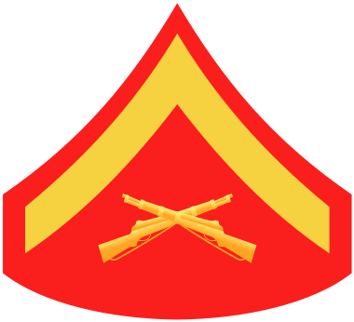
E-4 | Petty Officer  Third Class | 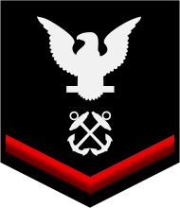 | Corporal | 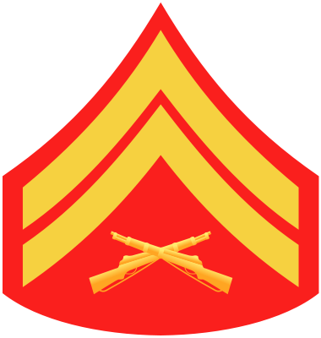
E-5 | Petty Officer  Second Class | 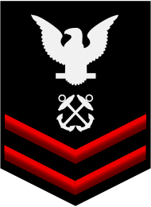 | Sergeant | 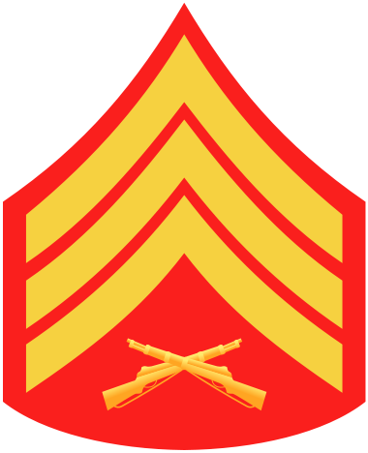
E-6 | Petty Officer  First Class | 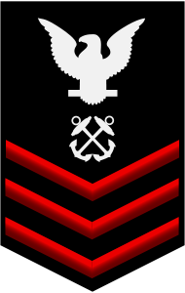 | Staff Sergeant | 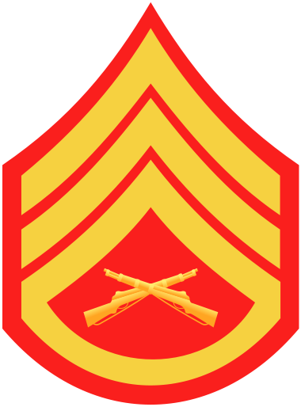
E-7 | Chief Petty Officer | 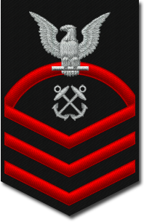 | Gunnery Sergeant | 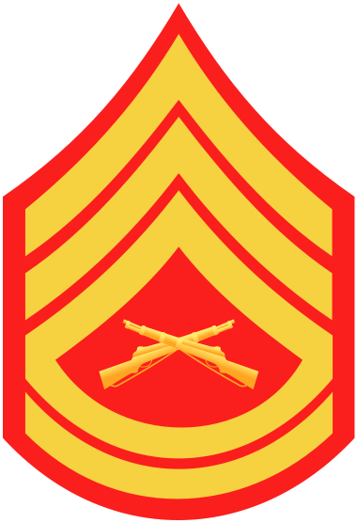
E-8 | Senior Chief  Petty Officer | 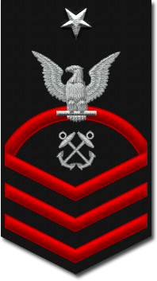 | Master Sergeant  First Sergeant | 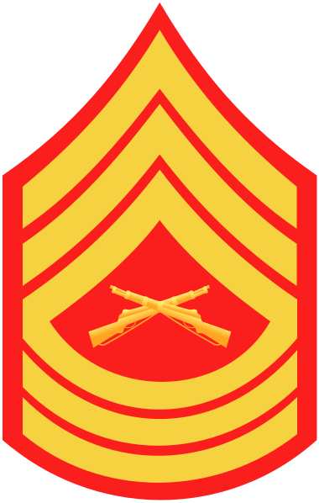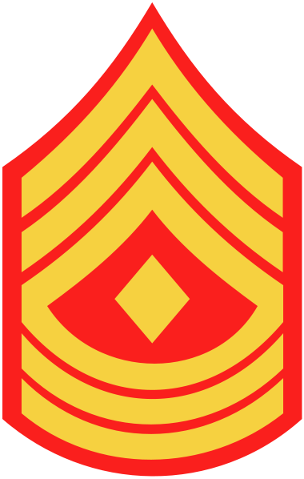
E-9 | Master Chief  Petty Officer | 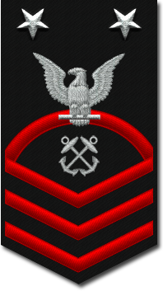 | Master Gunnery Sergeant  Sergeant Major | 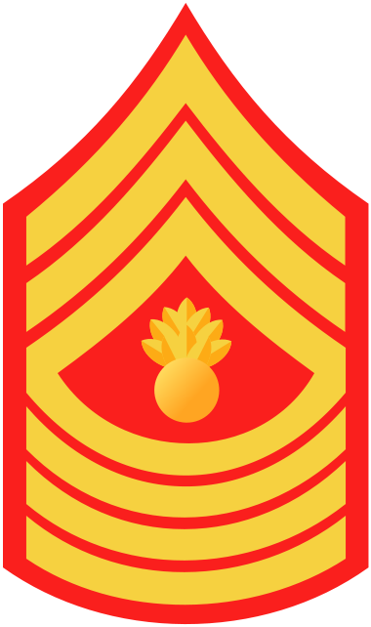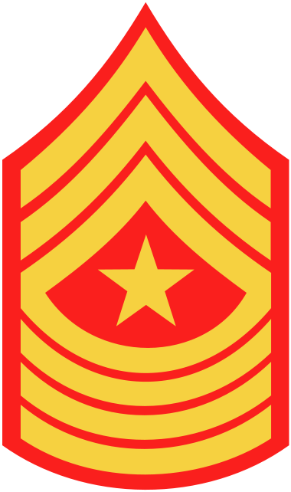
E-9 | Master Chief  Petty Officer  of the Navy | 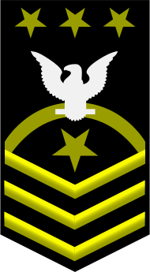 | Sergeant Major of the Marine Corps | 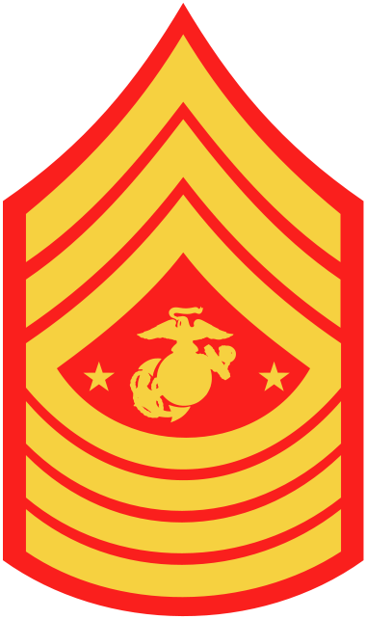

17. United States Navy/Marine Corps Officer Ranks:

Pay Grade | Rank | Abbreviation | Collar | Shoulder | Sleeve
O-1 | Ensign/2nd Lieutenant | ENS/2ndLt
O-2 | Lieutenant  Junior Grade/1st Lieutenant | LTJG/1stLt
O-3 | Lieutenant/Captain | LT/Capt
O-4 | Lieutenant  Commander/Major | LCDR/Maj
O-5 | Commander/Lieutenant Colonel | CDR/LtCol
O-6 | Captain/Colonel | CAPT/Col | 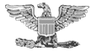
O-7 | Rear Admiral  (lower half)/Brigadier General | RDML/BGen
O-8 | Rear Admiral  (upper half)/Major General | RADM/MajGen
O-9 | Vice Admiral/Lieutenant General | VADM/LtGen
O-10 | Admiral/General | ADM/Gen
O-11 | Fleet Admiral/No equivalent for USMC | FADM

18. United States Navy Warrant Officer Ranks:

Pay Grade | Rank | Abbreviation | Collar | Shoulder | Sleeve
W-1 | Warrant Officer | WO1
W-2 | Chief  Warrant Officer | CWO2
W-3 | Chief  Warrant Officer | CWO3
W-4 | Chief  Warrant Officer | CWO4
W-5* | Chief  Warrant Officer | CWO5

19. United States Marine Corps Warrant Officer Ranks:

Pay Grade | Rank | Abbreviation | Collar
W-1 | Warrant Officer | WO1
W-2 | Chief  Warrant Officer | CWO2
W-3 | Chief  Warrant Officer | CWO3
W-4 | Chief  Warrant Officer | CWO4
W-5 | Chief  Warrant Officer | CWO5

20. Anchors Aweigh:

Stand Navy out to sea
Fight our battle cry;
We'll never change our course
So vicious foes steer shy-y-y-y
Roll out the T. N. T.
Anchors Aweigh
Sail on to victory
And sink their bones to Davy Jones, hooray!

Anchors Aweigh my boys
Anchors Aweigh
Farewell to college joys (or "Farewell to foreign shores")
We sail at break of day-ay-ay-ay
Through our last night ashore
Drink to the foam
Until we meet once more
Here's wishing you a happy voyage home!

Blue of the Mighty Deep
Gold of God’s great sun
Let these our colors be
Till all of time be done, done, done, done
On seven seas we learn
Navy’s stern call
Faith, Courage, Service True
With Honor Over, Honor Over All.

21. Marines’ Hymn:

From the Halls of Montezuma
To the Shores of Tripoli;
We fight our country's battles
In the air, on land and sea; First to fight for right and freedom And to keep our honor clean;
We are proud to claim the title
of United States Marine.

Our flag's unfurled to every breeze
From dawn to setting sun;
We have fought in ev'ry clime and place
Where we could take a gun;
In the snow of far-off Northern lands
And in sunny tropic scenes;
You will find us always on the job--
The United States Marines.

Here's health to you and to our Corps
Which we are proud to serve
In many a strife we've fought for life
And never lost our nerve; If the Army and the Navy
Ever look on Heaven's scenes;
They will find the streets are guarded
By United States Marines.

